**Mobile Monitoring Application: Enrollment of MSU-Marawi City**

Student enrollment mobile monitoring application is designed to cater the needs of students which is to monitor the enrolled subjects and its statement of account during enrollment in the university. Mobile monitoring application will use phonegap and will run in mobile android platform. In mobile monitoring application, students can view their computerized preliminary registration form where their enrolled subjects and statement of account details will be shown. It will also show the statuses of computerized preliminary registration form if it is already printed, the statement of account if it is already paid and the certificate of registration is already printed too. In this mobile version, the students will be lessen in falling line in there designated enrolling officer to monitor and check their computerized preliminary registration form.

Student enrollment mobile monitoring application is a web based mobile application to be accessed in any android mobile devices that is connected to the network of MSU main campus. This mobile application will have a connection or an access of student data in database. The user or actor of this mobile application is a bonafide student of Mindanao State University in Marawi City. This enrolment mobile application is in need of active student Akan account in order to use it. Student Akan account is secured from Information Systems Department of College of Information Technology.

**Network Architecture**

The network architecture of this mobile application is N-tier client–server architecture specifically the thin-Client Wireless Client–Server. The enrolment monitoring mobile application will be installed in an android mobile device and connected to a router through wireless connection. The wireless router is then connected to MSU database server where the student’s profiles can be accessed. Figure 1 is a network architecture illustration of this mobile application.

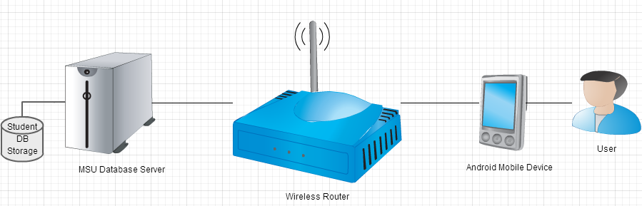

Figure 1: Network Architecture Diagram

**USE CASES:**

Name: Login

Description: Student will do the login to access their Mobile Akan Account.

Duration: 4 hours

Actor: Student

Pre-conditions: Student must have an active Akan account.

Post-conditions: Student can now see its computerized preliminary registration form.

Main Course:

1. The student enters its ID number and password.

Exceptions:

1a. Student ID number and password is invalid on first try, repeat step 1.

1b. Student ID number and password is invalid on second try.

The student needs to see the database administrator to check its akan account.

Use case exits.

1. The system shows the computerized preliminary registration form of the student.

The use case exits.

Name: Computerized Preliminary Registration Form (CPRF)

Description: List of student currently enrolled subjects, section, unit and total units.

Duration: 5 hours

Actor: Student

Pre-conditions: Student must successfully login.

Post-conditions: Student can now see the list of currently enrolled subjects and its section only.

Main Course:

* 1. The system can see its list of currently enrolled subjects and its section and unit.

Alternatives

1a. No subjects currently enrolled.

The student must see its adviser or their enrolling officer.

The use case exits.

Name: Subject Details

Description: Show the details of a subject like course code, title description, section, instructor, room and unit.

Duration: 4 hours

Actor: Student

Pre-conditions: List of currently enrolled subjects.

Post-conditions: Details of a certain subject.

Main Course:

* 1. The student select one subject to be viewed its details.
  2. The system shows the details of the selected subject.

Alternatives

1a. Student don’t like the subject and/or the schedule.

The student must see its adviser or their enrolling officer to change it.

The use case exits.

Name: CPRF Status

Description: Shows the status of CPRF whether it is already printed and ready for payment at the cashier.

Duration: 4 hours

Actor: Student

Pre-conditions: Student must successfully login.

Post-conditions: Shows the CPRF status if it is already printed or not.

Main Course:

* 1. The student checks the status of its CPRF.
  2. The CPRF is not yet printed.
  3. The student must see its adviser or their enrolling officer to have it printed.

The use case exits.

Name: Statement of Account (SOA)

Description: Show the student billing details.

Duration: 6 hours

Actor: Student

Pre-conditions: Student must have an enrolled subjects.

Post-conditions: Shows the student statement of account details.

Main Course:

* 1. The student selects the statement of account in CPRF view.
  2. The system shows billing details.

The use case exits.

Name: Statement of Account Status

Description: It will show the status of billing if it is already paid and ready for printing of certificate of registration.

Duration: 4 hours

Actor: Student

Pre-conditions: Must be in statement of account view.

Post-conditions: Shows the SOA status if it is already printed or not.

Main Course:

* 1. The student checks the status of its SOA.
  2. The SOA is not yet mark as paid.
  3. The student must see the cashier.

The use case exits.

Name: Certificate of Registration (COR)

Description: Show the student official enrolled subjects.

Duration: 10 hours

Actor: Student

Pre-conditions: Student statement of account must be settled.

Post-conditions: Shows the COR details.

Main Course:

* 1. The student must go to their designated COR printer for their COR printing.

The use case exits.

Name: Download Database Software

Description: Download a database software where to be used as student data storage temporarily.

Duration: 4 hours

Actor: Developer

Pre-conditions: Developer’s computer connected to the internet.

Post-conditions: downloaded database software.

Main Course:

* 1. The developer enters the name of database software in the browser.
  2. The developer selects the link of database software.
  3. Download the selected database software.
  4. The computer downloads and save the database software.

Use case exits.

Name: Install Database Server

Description: Install database server where to hold student data temporarily.

Duration: 4 hours

Actor: Developer

Pre-conditions: Database server is already downloaded.

Post-conditions: developer’s computer has an installed database.

Main Course:

* 1. The developer selects a database server software to be installed.
  2. The computer installed the database server software.

Use case exits.

Name: Configure Database Server

Description: Configure database server for mobile project app.

Duration: 4 hours

Actor: Developer

Pre-conditions: Must have a database server installed.

Post-conditions: Working database server.

Main Course:

* 1. The developer selects the database application icon to run.
  2. The computer runs the database server software.
  3. The developer configure and checks its configuration.
  4. The computer saves the configuration.

Use case exits.

Name: Project Database

Description: Creation of tables, references, constraints and sample data.

Duration: 10 hours

Actor: Developer

Pre-conditions: Working database server.

Post-conditions: Metadata of the project.

Main Course:

* 1. The developer selects the database application icon to run.
  2. The computer runs the database server software.
  3. The developer creates a new database.
  4. The developer creates appropriate tables.
  5. The developer enters sample data on tables created.

Use case exits.

Name: Connect Database

Description: Connect project to Database.

Duration: 10 hours

Actor: Developer

Pre-conditions: Database must already exist with sample data.

Post-conditions: Mobile app project connected to database.

Main Course:

* 1. The developer creates a java class for database connection.
  2. The developer enters codes for the connection.

2a. The java class failed to connect to database server.

Repeat step 2.

Use case exits.

Name: Deployment of Mobile Monitoring Application

Description: It is the final deployment of the created mobile monitoring application into an emulator or real device.

Duration: 5 hours

Actor: Developer

Pre-conditions: Mobile app must be working properly.

Post-conditions: Mobile app installed in a real android mobile device.

Main Course:

* 1. The developer selects the mobile app project to run.
  2. The developer selects the real mobile device where to run the mobile app.
  3. The computer will run and install the mobile app into real android mobile device.
  4. The developer try and check the installed mobile app.
  5. If mobile app is not working properly. Repeat step 1.

Use case exits.

Each use case defined has an appropriate estimated time in hours to complete the task. To sum up the number hours of each use case, the total is 74 hours. This 74 hours is exclusive the time of researching and reading of related studies, and exploring and experimenting of codes found. The time consumed in doing research and exploring codes is more than 100 hours and it is still counting. The total estimated hours to complete this mobile application is almost 200 hours. The figure 2 shows the total estimated time to complete the development of this enrolment monitoring mobile application and figure 3 shows the actual development progress of enrolment monitoring mobile application.

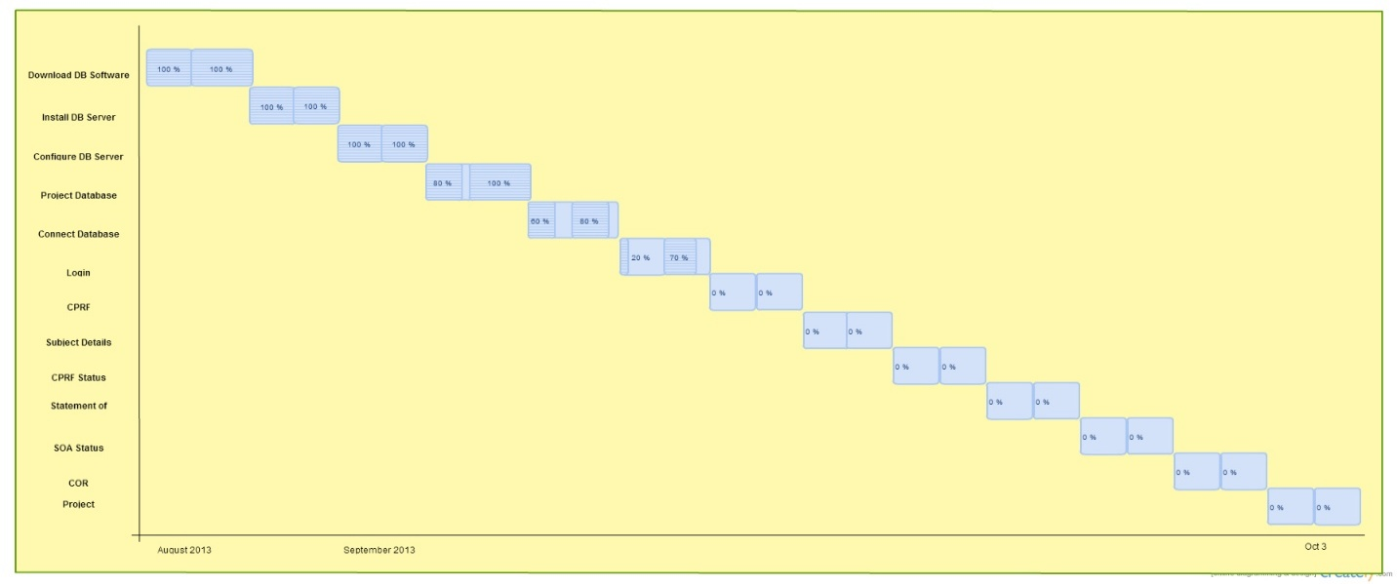

Figure 2: Gantt Chart

Figure 3: Burn Down Chart